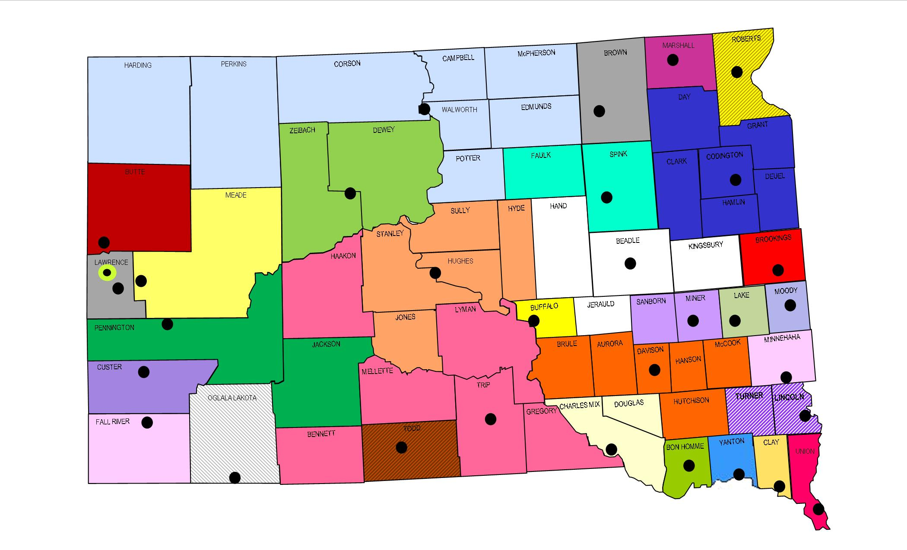
Public Safety Answering Points

Bon Homme County 911 (SO)  Amanda Boden  PO Box 1, 300 W 18th Ave.  Tyndall, SD 57066-0001  P: 605.589.3942 F: 605-589-4209  E: amandajboden@gmail.com | Brookings Police Department  JoLynn Longville  307 3rd Avenue  Brookings, SD 57006  P: 605.692.2113 F: 605.692.5320  E: jlongville@brookingsleo.org | Brown County Communications  Kent Jones  124 S 1st Street  Aberdeen, SD 57401  P: 605.626.4000 F: 605.626.4003  After 5pm: 605.626.7911  E: Kent.Jones@browncounty.sd.gov
Butte County Dispatch Center (SO)  Vicki Greenwood  839 5th Avenue, Ste. 5  Belle Fourche, SD 57717  P: 605.892.2737 F: 605-892-2738  E: vicki.greenwood@buttesd.org | Central South Dakota Communications  Cindy Gross  1302 E HWY 14, Suite 9  Pierre, SD 57501  P: 605.773.7410 F: 605.773.7424  E: Cindy.Gross@ci.pierre.sd.us | Charles Mix County 911 (SO)  Sheriff Randy Thaler  PO Box 610  215 S 6th Avenue  Lake Andes, SD 57356  P: 605.487.7625 F: 605.487.7198  E: 171a@cme.coop
Clay Area Emergency Services Communication Center  Ryan Anderson  15 Washington Street  Vermillion, SD 57069  P: 605.677.7070 F: 605.677.7165  E: randerson@claycomm.org | Custer County Communications Ctr  Michelle Lyon  420 Mount Rushmore Road  Custer, SD 57730  P: 605.673.8146 F: 605.673.3765  After 5pm: 605.673.8176  E: mboehrs@custercountysd.com | Fall River County Sheriff’s Office  Dave Weishaupl  906 N River Street  Hot Springs, SD 57747  P: 605.745.4444 F: 605.745.7591  E: dave.w@frcounty.org
Huron Police Department DPS  Lisa McWethy  239 Wisconsin Avenue SW  PO Box 1369  Huron, SD 57350  P: 605.353.8550 F: 605.353.8554  E: lisam@huronpolice.com | Lake County 911 Communications  April Denholm  219 NE 1st Street  Madison, SD 57042  P: 605.256.7620 F: 605.256.7160  E: lake911@lake.sd.gov  dispatch@lake.sd.gov | Lawrence County Sheriff’s Office  Jamie Pesicka Olson  PO Box 405, 80 Sherman St. Ste #1  Deadwood, SD 57732  P: 605.578.4464 F: 605.578.3913  After 5pm: 605.578.2230  E: jpesicka@lawrence.sd.us
Lincoln County Communications  Todd Baldwin  128 North Main Street  Canton, SD 57013  P: 605.764.2664 F: 605.764.2767  E: lccc@lincolncountysd.org | Marshall County 911  Deb Skonberg  911 Vander Horck, PO Box 9  Britton, SD 57430  P: 605.448.5181 F: 605.448.5927  E: skonbergd02@yahoo.com | Meade County Telecom (SO)  Scott Johnson  1400 Main Street  Sturgis, SD 57785  P: 605.347.2681 F: 605.347.6824  E: sjohnson@meadecounty.org

Metro Communications Agency  Scott McMahon  500 N Minnesota Avenue  Sioux Falls, SD 57104  P: 605.367.7222 F: 605.367.7854  E: smcmahon@911metro.org | Miner County Dispatch  Cora Schwader  PO Box 366, 400 N Main  Howard, SD 57349-0366  P: 605.772.4501 F: 605.772.4148  E: minerdispatch@alliancecom.net | Mitchell Regional 911  Dawn Niehoff  201 West 1st Avenue  Mitchell, SD 57301  P: 605.995.8400  E: dawnn@mitchelldps.com
Moody County 911  Ken Prorok  108 E Pipestone Avenue  Flandreau, SD 57028  P: 605.997.2423  E: kprorok521g@moody.sd.gov | North Central Regional E911 Center  Tammie Fischer  110 1st Ave. East  Mobridge, SD 57601  P: 605.845.5000 F: 605.845.2034  E: tammie.fischer@mobridgepolice.org | Pennington County 911  Kevin Karley  130 Kansas City St, Ste 110  PO Box 6160  Rapid City, SD 57701  P: 605.394.2192 F: 605.394.6795  E: kevin.karley@pennco.org
Roberts County Sheriff’s Office  Alexis Johnson  11924 BIA HWY 700, Box 937  Sisseton, SD 57262  P: 605.698.7667 F: 605.698.7386  E: 911@robertsco.org | Spearfish Police Department  Jude Warner  225 W Illinois Street  Spearfish, SD 57783  P: 605.642.1300 F: 605.642.1315  E: Judith.warner@cityofspearfish.com | Spink County Sheriff’s Office  Frank Krumm  210 East 7th Avenue  Redfield, SD 57469  P: 605.472.4595 F: 605.472.4599  E: 571a@midconetwork.com
Union County Sheriff’s Office  Sara Beatty  209 East Main Street, Ste. 250  Elk Point, SD 57025  P: 605.356.2679 F: 605.356.3356  E: Sara.Beatty@unioncountysd.org | Watertown Police Department  Troy VanDusen  128 North Maple  Watertown, SD 57201-3653  P: 605.882.6210 (DL 5621)  F: 605.882.5246  E: tvandusen@watertownpd.com | Winner Police Department  Deb Bice  217 East 3rd Street  Winner, SD 57580-0691  P: 605.842.3324 F: 605.842.0415  E: wincomsd@goldenwest.net  911dispatch@gwtc.net
Yankton Police Department
Julia Hussein
410 Walnut St., Suite 102
Yankton, SD 57078
P: 605.668.5210 F: 605.668.5203
E: jhussein@cityofyankton.org
State 9-1-1 Coordinator
Maria King
Department of Public Safety
118 W Capitol Avenue
Pierre, SD 57501
P: 605.773.3264 F: 605.773.3018
E: Maria.King@state.sd.us
TRIBAL PSAPs
BIA Law Enforcement Ctr Crow Creek  Donovan Wind Sr.  PO Box 110, 125 Wizi Street  Fort Thompson, SD 57339-0110  P: 605.245.2351 F: 605.245.2159  E: Donovan.wind@bia.gov | Cheyenne River Tribe 911  Lieutenant Joe Brings Plenty  PO Box 590, 2105 D Street  Eagle Butte, SD 57625  P: 605.964.4567 F: 605.964.1023  E: Jessica.LeBeau@CRSTPD.com | Oglala Sioux Tribe - DPS  Eula Yellow Boy  PO Box 300  977 Horse Thief Road  Pine Ridge, SD 57770  P: 605.867.5111 F: 605-867-5936  E: Eyellowboy@ostdps.org
Rosebud Tribal Police Department
Sylvia Wright
1 Fairground Road
Rosebud, SD 57570
P: 605.856-2365 F: 605.747.5010
E: daisy.wright@rstjustice.org

